# **Eventium Application - Django Basics Regular Exam**

**22 June 2025**

*The app allows users to browse events, including their details and banner images. They can create, edit, or delete events and see, edit, or delete their organizer profiles.*

## Skeleton

All essential **HTML** pages, **images**, and **CSS** resources for the project have been provided to you.

## Structure

Establish a well-organized project structure by initiating **at least** **two** Django **apps** and configuring the **corresponding URLs**.

You have the flexibility to utilize **both** **Function-Based Views** and **Class-Based Views** as needed.

Adhere to best practices and uphold the separation of concerns principle for a robust and maintainable codebase.

If there are **no explicitly** **defined** requirements for formatting or additional functionalities, it implies that **you** **are** **not obligated** to **implement** **them** unless you have ample time and wish to enhance your project. However, **ensure** that you **fully satisfy** **all explicitly defined** ones.

## Database

You will need **two models**:

### Organizer

* + **company_name**
    - **Character** field, **required**, **unique**.
    - It should consist of **110 characters maximum** and **2 characters minimum**.
    - The company name **can contain only letters**, **digits**, **spaces**, and **hyphens**. Otherwise, raise **ValidationError** with the following message: "**The company name is invalid!**"
    - Help text: **"*Allowed names contain letters, digits, spaces, and hyphens."**
  + **phone_number**
    - **Character** field, **required**, **unique**.
    - It should consistof **digits only**, **15 maximum**.
    - A custom **error message** fora **unique constraint**: **"That phone number is already in use!"**
  + **secret_key**
    - **Character** (password input) field, **required**.
    - It should consistof **exactly 4 unique digits**. Otherwise, raise **ValidationError** with the following message: **"Your secret key must have 4 unique digits!"**
    - Help text: **"*Pick a combination of 4 unique digits."**.
  + **website**
    - **URL** field, **optional**.

### Event

* + **slogan**
    - **Character** field, **required**.
    - It should consist of **120 characters maximum** and **2 minimum**.
  + **location**
    - **Character** field, **required**.
    - It should consist of **120 characters maximum** and **2 minimum**.
  + **start_time**
    - **Datetime** field, **required**.
    - **Default** value: **Current datetime**.
  + **available_tickets**
    - **Integer** field, **required**.
    - **Minimum** value: **0**.
  + **key_features**
    - **Text** field, **optional**.
  + **banner_url**
    - **URL** field, **optional**.
  + **organizer**
    - A **foreign key** to the **Organizer** model.
    - Establishes a **many-to-one** relationship with the **Organizer** model, associating each event with an organizer.
    - The **ON DELETE** constraint must be **configured** to an **appropriate value** in alignment with the specified **additional tasks**.
    - This field should remain **hidden** in forms.

**\*Note: Validations** will be **assessed solely** on the **user side** using navigational links and displayed pages (**no evaluation** from the **Django Admin site** will be performed).

## Routes

* <http://localhost:8000/> - Index page
* <http://localhost:8000/events/> - Events page
* [http://localhost:8000/events/create/](http://localhost:8000/posts/create/) - New Event Create page
* [http://localhost:8000/events/<event_pk>/details/](http://localhost:8000/events/%3cevent_pk%3e/details/) - Event Details page
* [http://localhost:8000/events/<event_pk>/edit/](http://localhost:8000/events/%3cevent_pk%3e/edit/) - Event Edit page
* [http://localhost:8000/events/<event_pk>/delete/](http://localhost:8000/events/%3cevent_pk%3e/delete/) - Event Delete page
* [http://localhost:8000/organizer/create](http://localhost:8000/author/create)/ - Organizer's Profile Create page
* [http://localhost:8000/organizer/details/](http://localhost:8000/author/details/) - Organizer's Profile Details page
* [http://localhost:8000/organizer/edit/](http://localhost:8000/author/edit/) - Organizer's Profile Edit page
* [http://localhost:8000/organizer/delete/](http://localhost:8000/author/delete/) - Organizer's Profile Delete page

## Pages

### Base Template - 5 points

**Template file**: **"base.html"**

Create a **base template** to be **inherited** by all other templates in the project. This base template should encompass project **metadata** within the <head> tag, along with a consistent **navigation bar** and **footer** for **each** web page.

**Navigation bar**:

* **Logo image** as a **link** that leads to the **Index** page.
* **"New Organizer"** link leads to the **Create Organizer's Profile** page.
* **"Events"** link, which leads to the **Events** page.
* **"New Event"** link leads to the **Create Event** page.
* **"Organizer's Profile"** link leads to the **Organizer's Details** page.

**Footer:**

* **"&copy; 2025 Eventium by SoftUni Team. All rights reserved."**
  + The **footer** is **consistent** across **all pages** and does **not change**.

Note that the **"New Organizer"** link on the navigation bar is **only visible** when the user **has NOT created** an organizer's **profile yet**, while the **"Events"**, **"New Event"**, and **"Organizer's Profile"** links are **only visible** when the user **has a profile**.

This template lacks a direct path and is **inaccessible** via **URL**.

### Index page - 5 points

**Template file**: **"index.html"**

The page displays:

* A **navigation bar** as described above
* A welcoming **heading**: **"Events Beyond Borders. Discover. Pick. Experience."**
* An **image** that you have in the resources folder (static/images/hero-img.png)
* A **footer** as described above

Keep in mind that the **"New Organizer"** link on the navigation bar is **only visible** when the user **has NOT created** an organizer's **profile yet**:

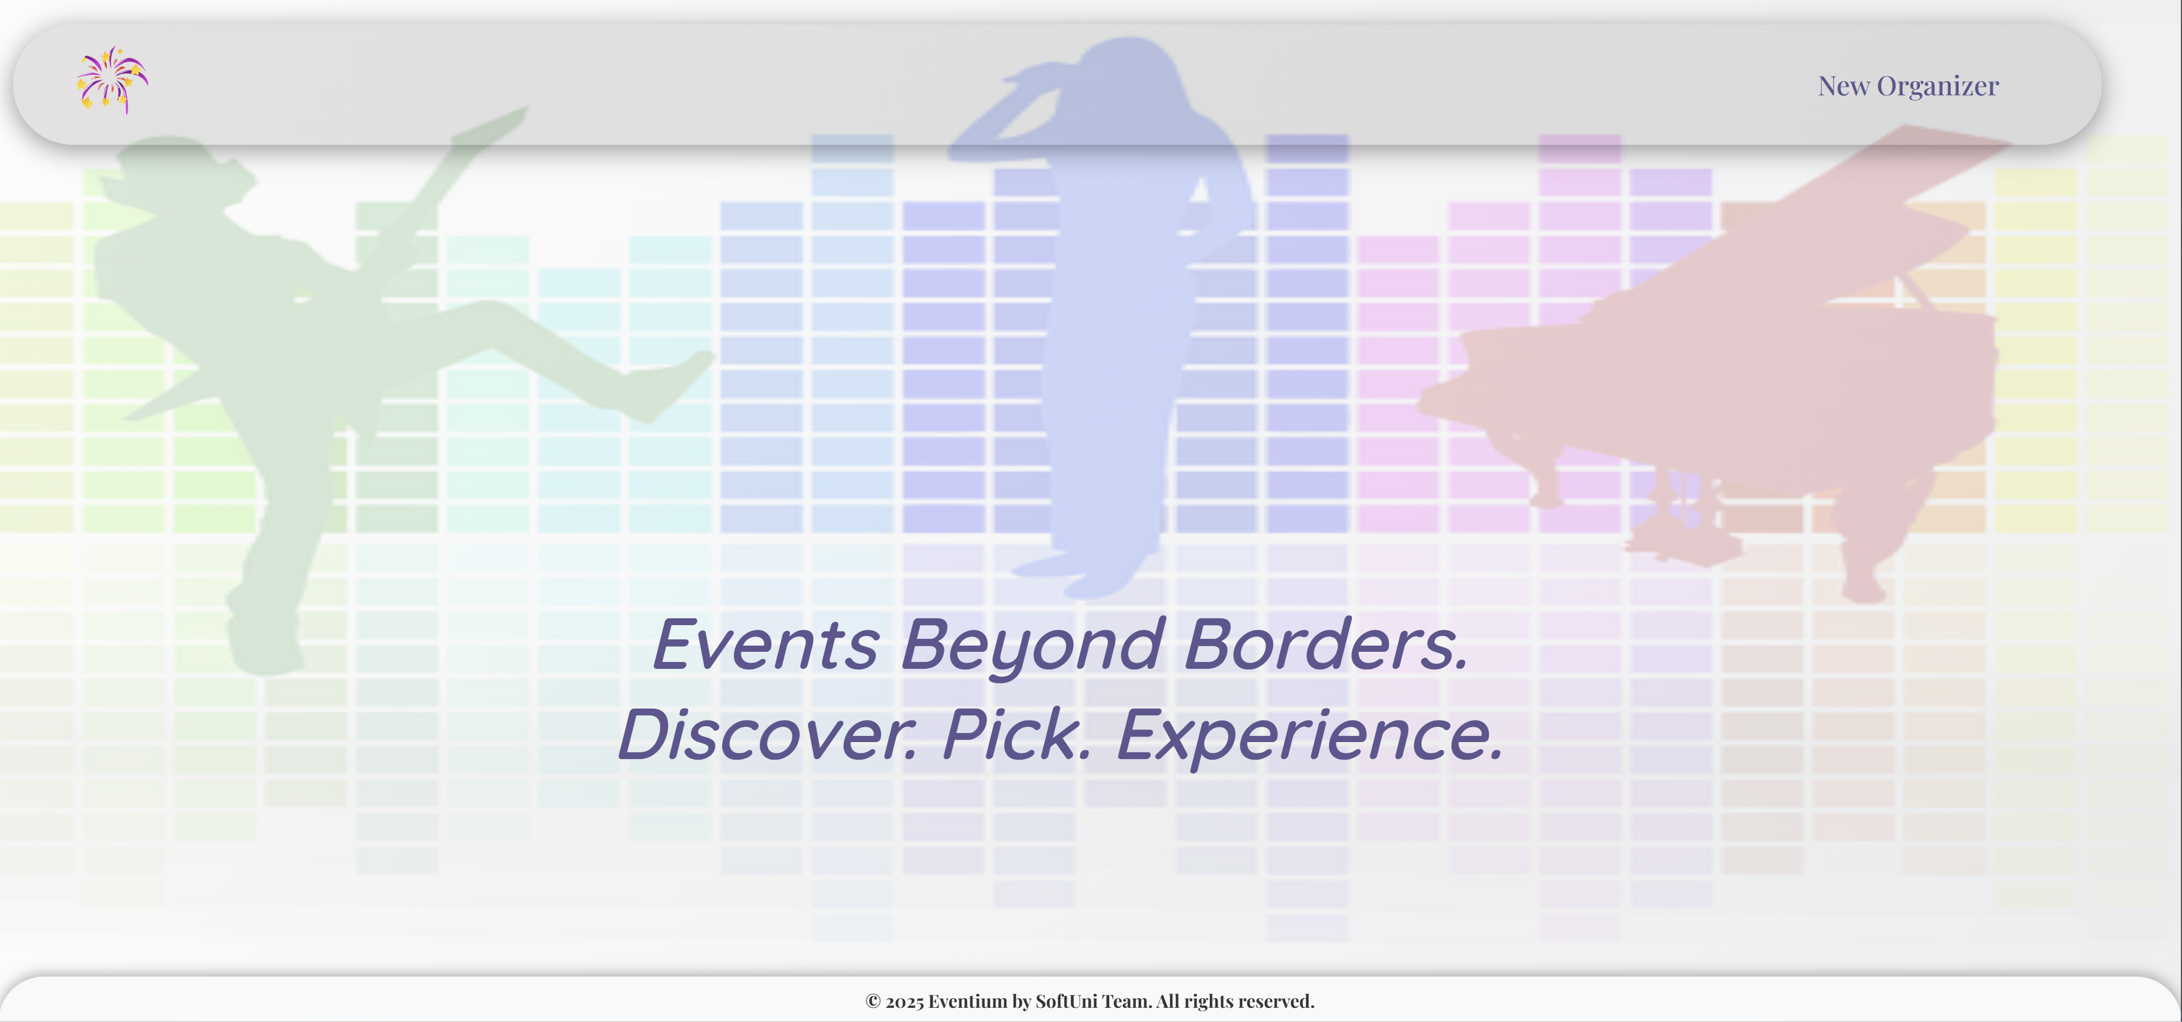

The **"Events"**, **"New Event"**, and **"Organizer's Profile"** links on the navigation bar are **only visible** when the user **has an organizer's profile**:

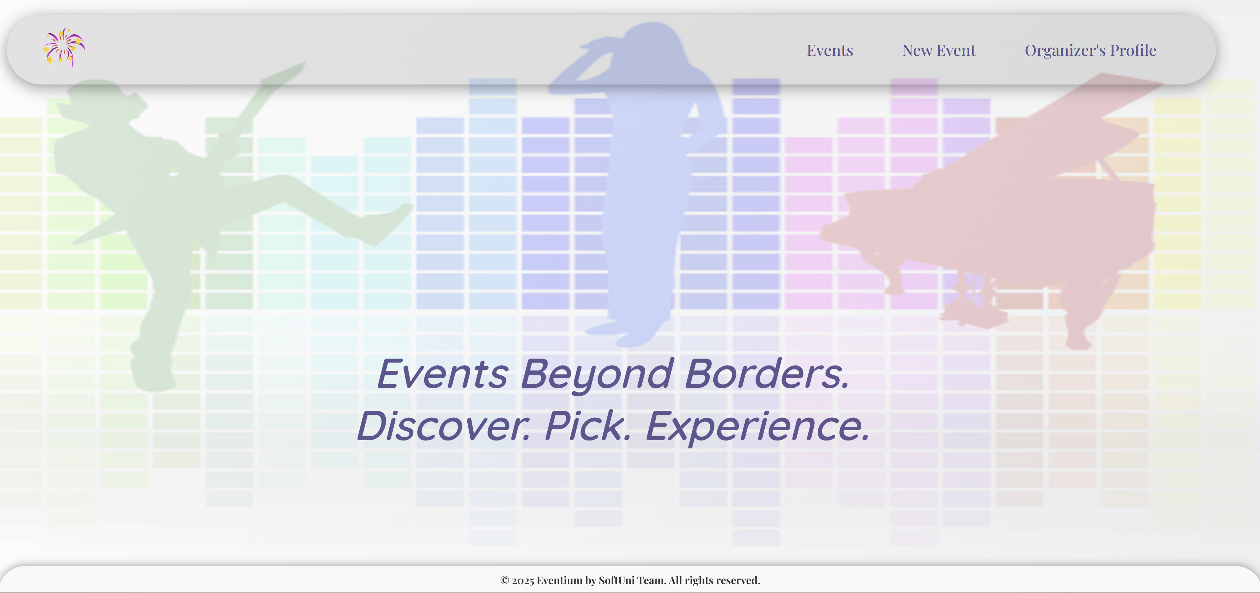

### Create Organizer's Profile Page - 10 points

**Template file**: **"create-organizer.html"**

The page displays:

* A **navigation bar** with:
* **Logo** link, which leads to the **Index** page.
* **"New Organizer"** link leads to the **Organizer's Profile Create** page.
* A new **organizer's** **profile** **creation form** consisting of:
* A **"Company Name"** field with:
  + a **label "Company Name:"**
  + a **help text** **"*Allowed names contain letters, digits, spaces, and hyphens."**
  + a **placeholder** **"Enter a company name..."**
* A **"Phone Number"** field with:
  + a **label "Phone Number:"**
  + a **placeholder** **"Enter a valid phone number (digits only)..."**
* A **"Secret Key"** field with
  + a **label** **"Secret Key:"**
  + a **help text** **"*Pick a combination of 4 unique digits."**
  + a **placeholder** **"Enter a secret key like <1234>..."**
  + When the user enters the secret key, the digits shall be **masked** (**not visible**).
* Utilize a suitable **widget** to **mask** **characters** for enhanced **security** and **privacy**.

A button **"Create"**

* When you **click** on it, **and** the profile is **successfully created**, you should be **redirected** to the **Events page**.
* Otherwise, the form should show the **appropriate validation errors**.

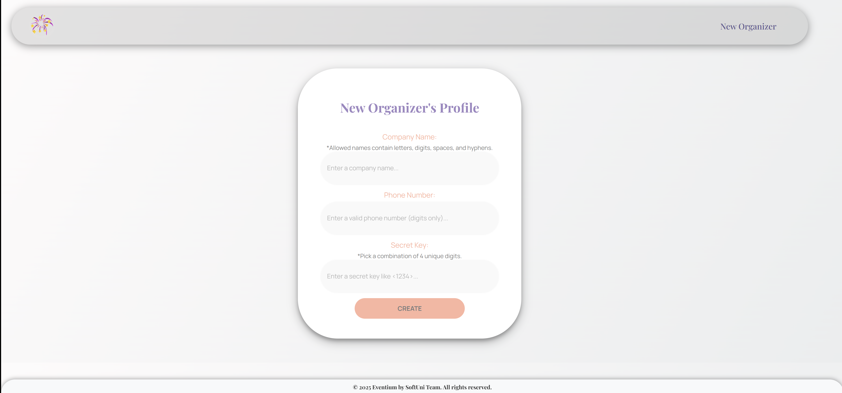

### Events Page - 10 points

**Template file**: **"events.html"**

The **page** shows **all events created** and **stored** in the **database**,in **descending order** by **start time**.

If there are **no events yet**, the page should have the following:

* A **navigation bar**, as shown below.
* A heading **"No events so far."**

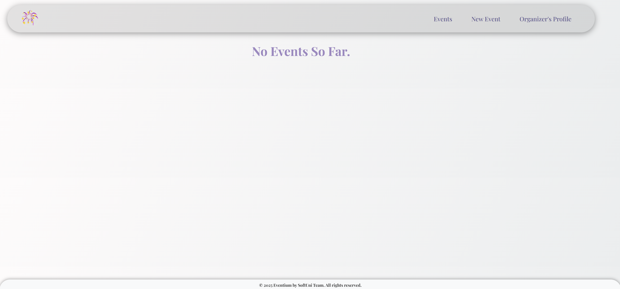

If there are **events**, **display** themin **descending order** by **start time**.The page should have the following:

* A **navigation bar**, as shown below.
* A heading **"We have <number>**  **events in total."**
* A card for **each event**, showing:
* The event's **slogan** (**up to 20 visible characters**)
* The event's **banner** **image**,if suchis **provided**, otherwise displays a **default event image** from resources(static/images/event-default-img.png)
* The event's **start time**. The **datetime** value is **displayed** in **"D d M Y H:i"** format
* The event's **location**
* A **button** **"Click for more"** (leads to the selected event's Details page)

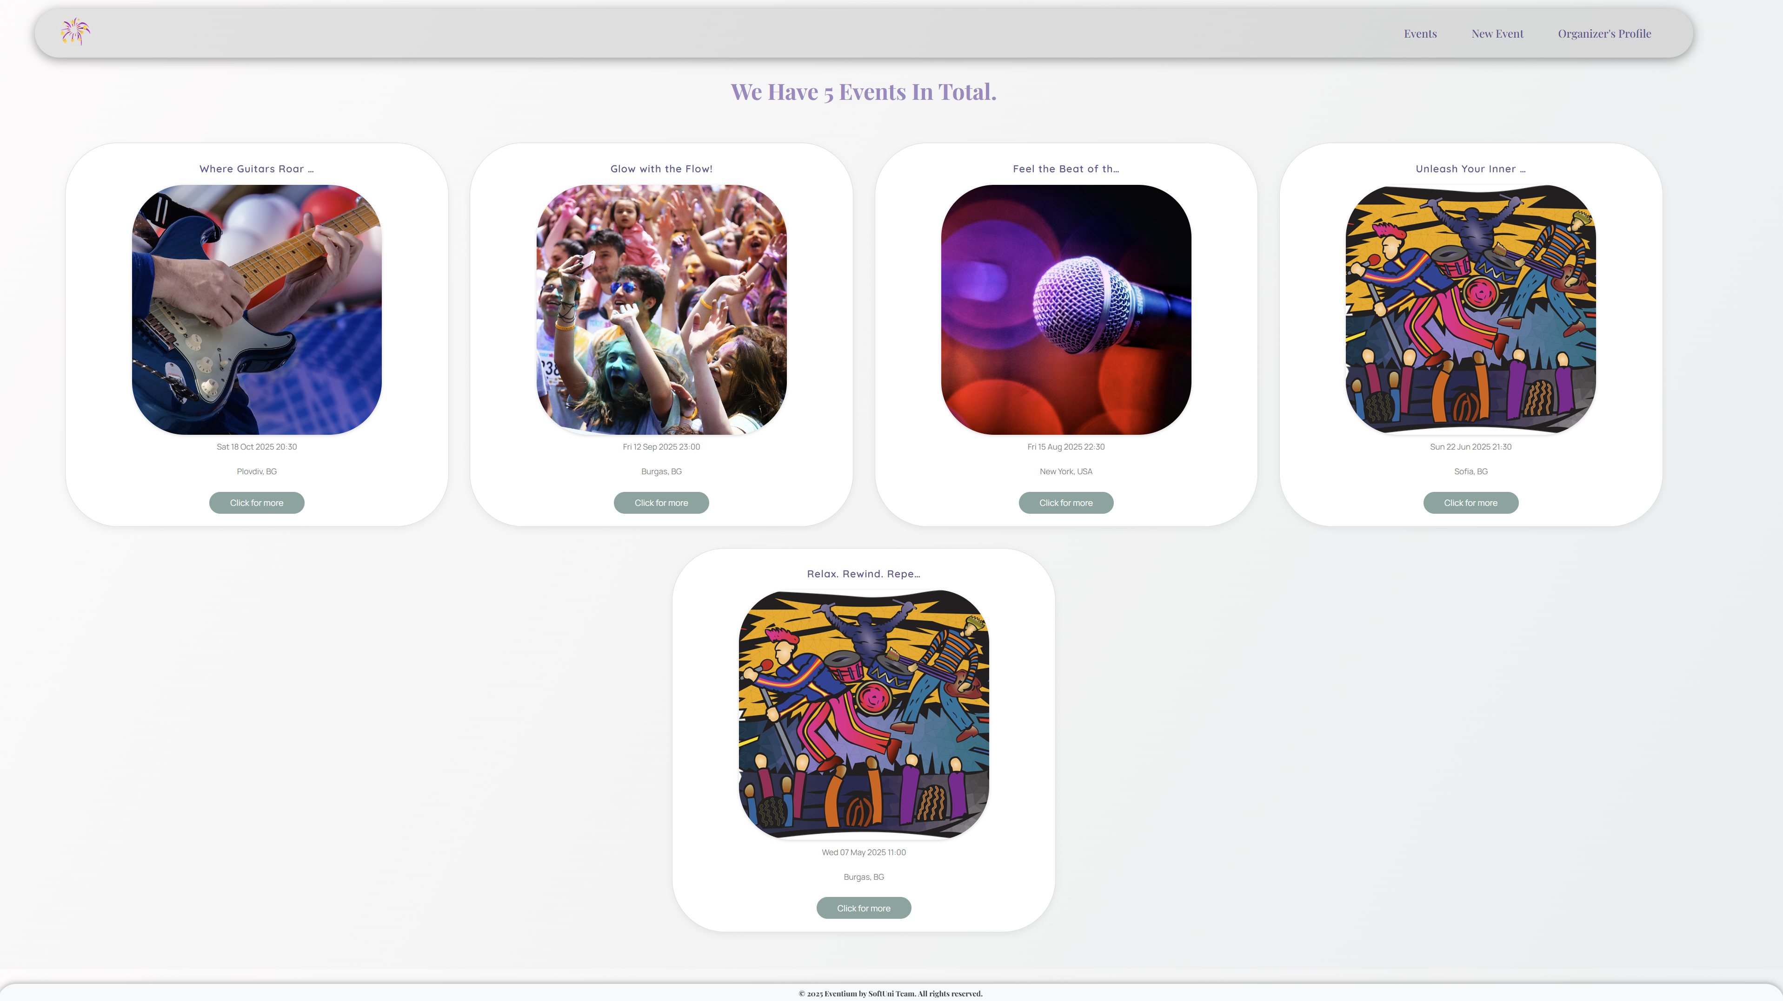

### Create Event Page - 10 points

**Template file**: **"create-event.html"**

The page consists of:

* A **navigation bar**, as shown below.
* A new **event** **creation form** consisting of:
* A **"Slogan"** field with:

a **label "Slogan:"**

a **placeholder** **"Provide an appealing text..."**

* A **"Location"** field with:
  + a **label "Location:"**
* An **"Event Date/Time"** (start_time) field with:
  + a **label "Event Date/Time:"**
  + a **prepopulated default** value: **current** datetime
  + **Note**: Using the appropriate **widget** for **datetime inputs** and **showing** a **calendar datetime picker** is **NOT** **required** - it is good practice and facilitates users. You **can** leave it as a **simple datetime field**, **defaulting** to the **current** datetime.
* An **"Available Tickets"** field with:
  + a **label "Available Tickets:"**
* An **"Event Key Features"** field with:
  + a **label "Event Key Features:"**
  + a **placeholder "Provide important event details..."**
* An **"Event Banner URL"** field with:
  + a **label "Event Banner URL:"**
  + a **placeholder "An optional banner image URL..."**
* A button **"Create event"**
* When you **click** on it, **and** the event is **successfully created**, you should be **redirected** to the **Events page**.
* Otherwise, the form should show the **appropriate validation errors**.
* **Associate** the new **event** with the **organizer's profile** you already have in the database (assuming there is only one profile).

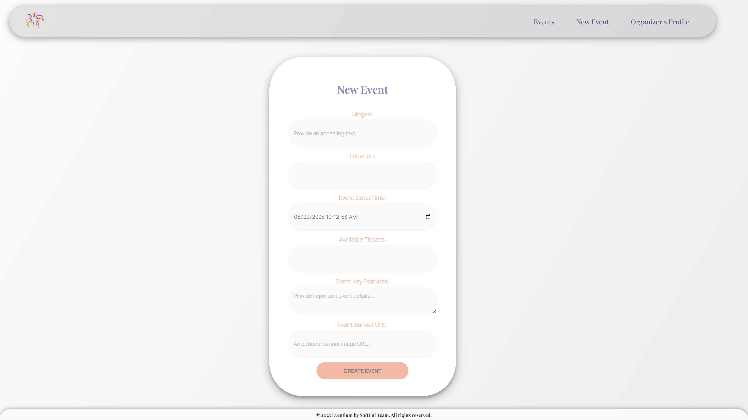

### Event Details Page - 10 points

**Template file**: **"details-event.html"**

This page contains the selected **event** information. It should have the following:

* The **event's banner image**,if suchis **provided**, otherwise displays a **default event image** from resources(static/images/event-default-img.png)
* The event's **slogan**
* The event's **start time**. The **datetime is displayed** in the **format**: **"D d M Y H:i"**
* The **event's location**
* The **event's available tickets**
* The **event's key features**, **if** **provided**. **Otherwise**, **do not display** the **paragraph**.
* An **"Edit"** button that leads to the **Edit Event page**
* A **"Delete"** button that leads to the **Delete Event page**

If an **event image** has been **provided**, and there are **key features**:

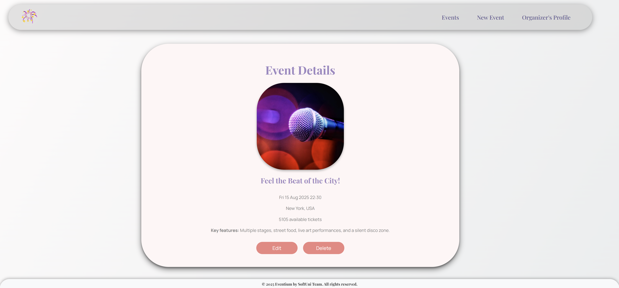

If there are **no key features** and **no event image** provided, display the **default** one:

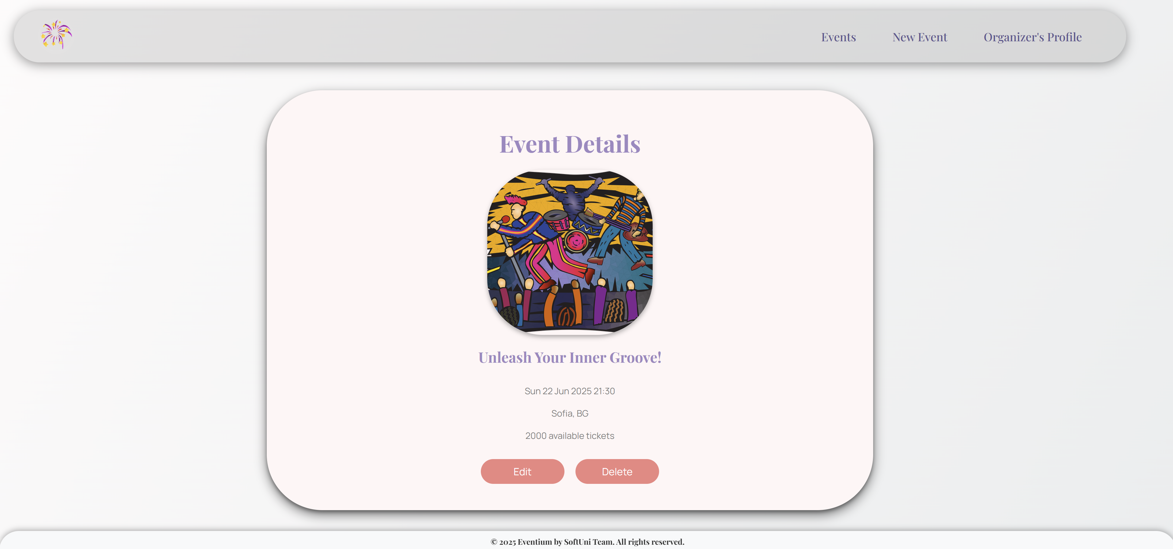

### Edit Event Page - 10 points

**Template file**: **"edit-event.html"**

On the page, the **form** must be **pre-filled** with **information** about the **event** you selected **to edit**.

Each field has a **label**: **"Slogan:"**, **"Location:"**, **"Event Date/Time:"**, **"Available Tickets:"**, **"Event Key Features:"**, and **"Event Banner URL:"**.

The **datetime picker** is **optional** and **NOT required**.

When you click the **"Edit"** button:

* If the **event** is **successfully edited**,you should be **redirected** to the **updated** **Event Details** **page**.
* **Otherwise**, the form should show the **appropriate validation errors**.

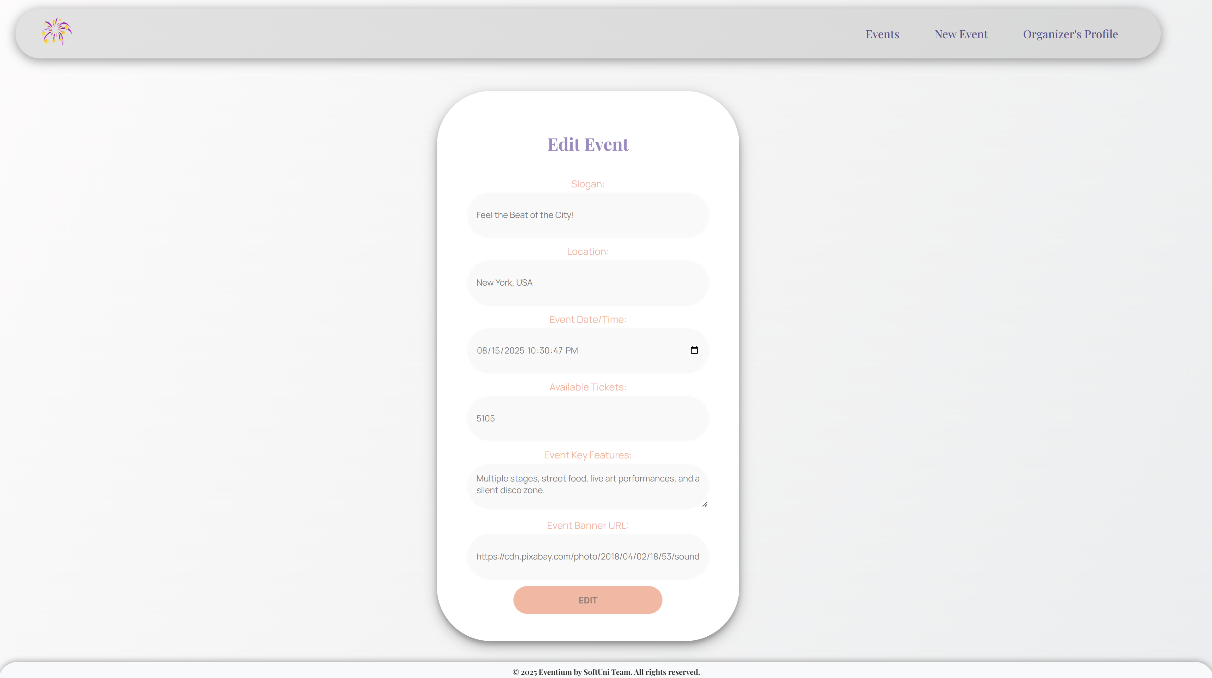

### Delete Event Page - 10 points

**Template file**: **"delete-event.html"**

On the page, the **form** must be **pre-filled** with the **event's information**, and **all the fields** should be **read-only**.

Each field hasa **label**: **"Slogan:"**, **"Location:"**, **"Event Date/Time:"**, **"Available Tickets:"**, **"Event Key Features:"**, and **"Event Banner URL:"**.

When you click the **"Delete"** button, the **event** is **deleted from the database**, and you should be **redirected** to the **Events page**.

The deleted event is **no longer visible** in the **app**.

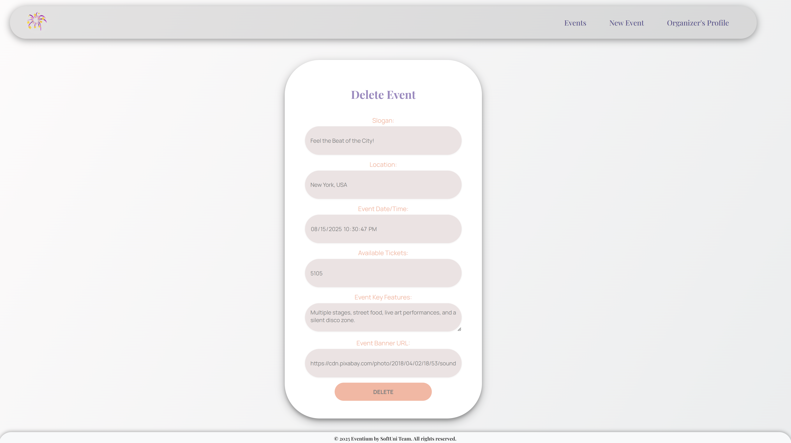

### Organizer's Profile Details Page - 10 points

**Template file**: **"details-organizer.html"**

This page contains the **organizer's profile information**. It should have the following:

* **Company name**
* A **default** **profile** **picture** from the resources folder (static/images/organizer-default.png)
* **Phone number**
* **Website**, if **provided**. Otherwise, do **not show** the paragraph.
* **Upcoming** **events** (**if any**, otherwise **skip** the **section**), **ordered by start time ascending**, in the **format**: **"{start_time_year}-{start_time_month}-{start_time_day} {start_time_hour}:{start_time_minute} {slogan} @ {location}"**
  + **Upcoming Events** are displayed in a **<ul>** element, where **each one** is in a **<li>** element.
  + **Note:** Display **only** the **upcoming events** (**start time** is **greater** than **'now'**)
* An **"Edit"** button that leads to the **Edit Organizer's Profile page**
* A **"Delete"** button that leads to the **Delete Organizer's Profile page**

If the **organizer has** a **website** and **upcoming events**:

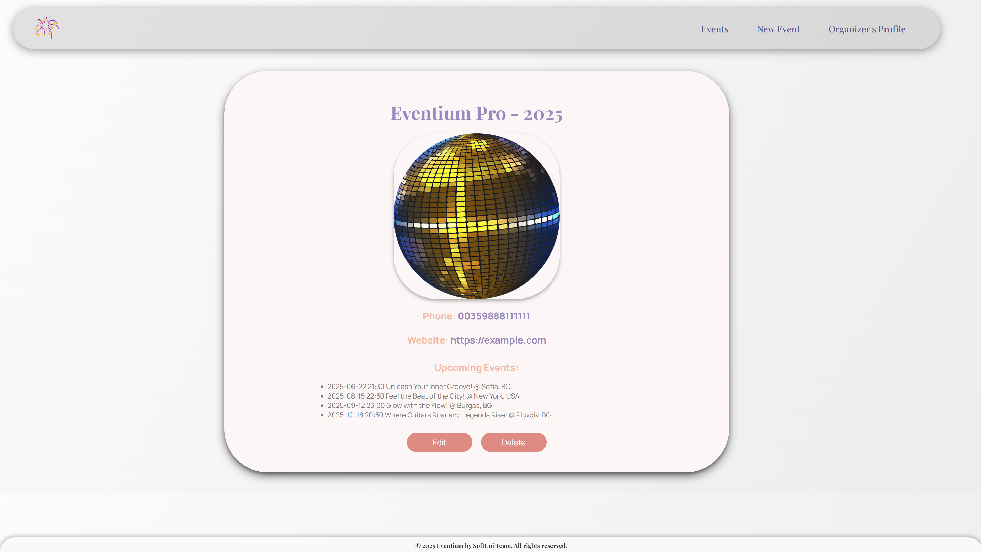

If there are **no upcoming events** and **no organizer's website**:

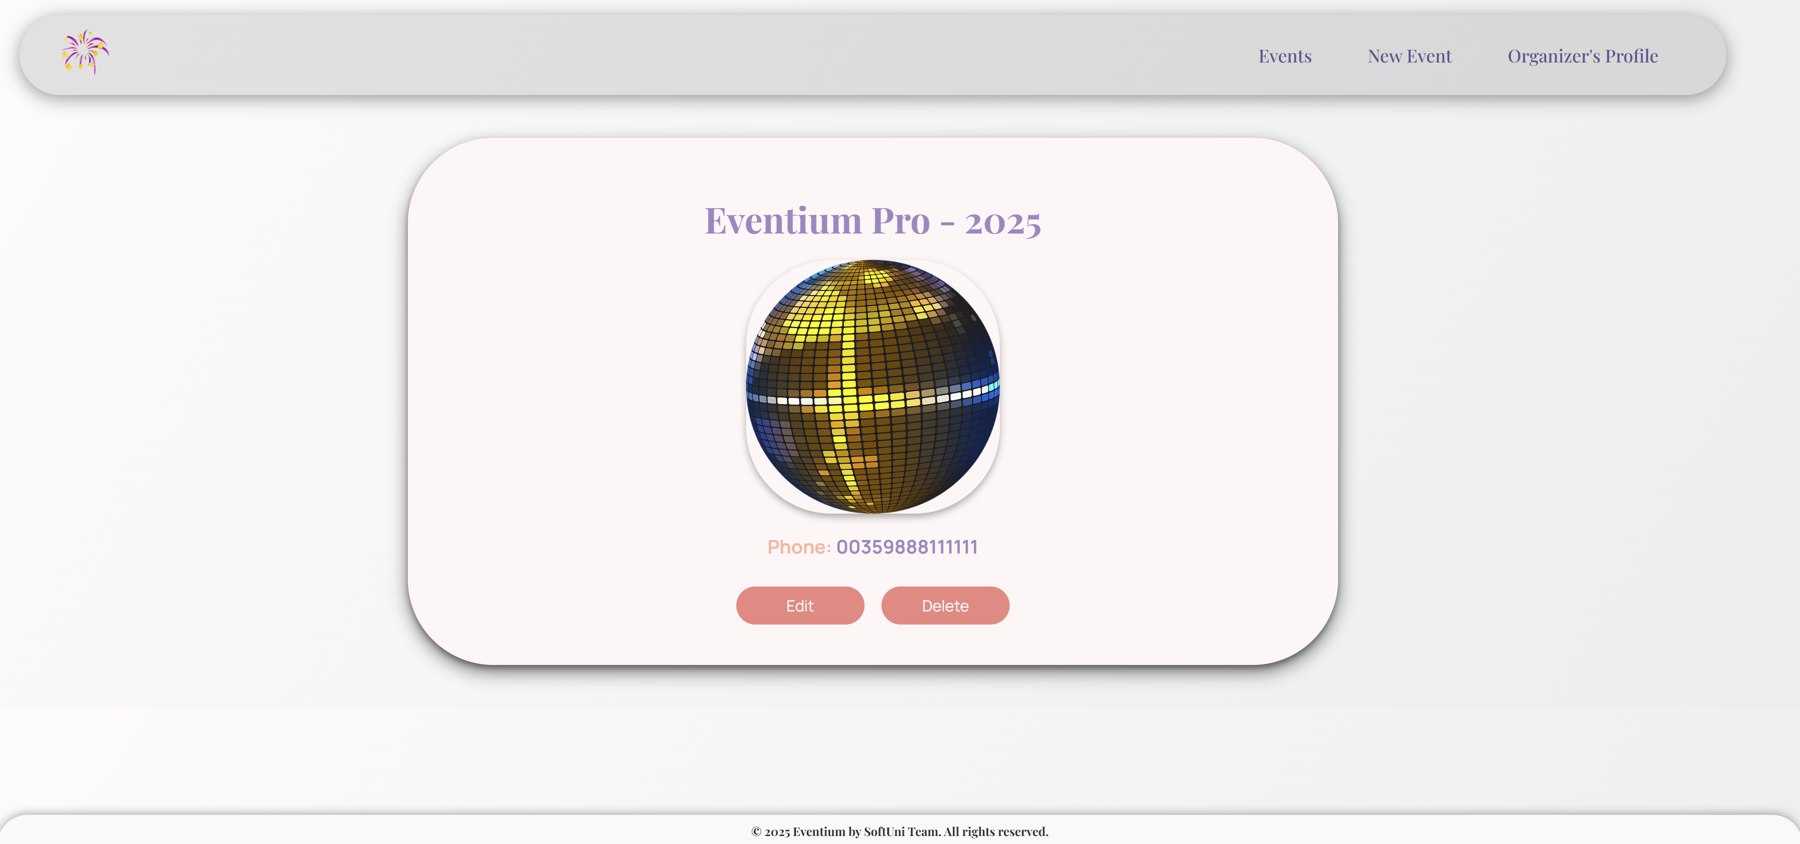

### Edit Organizer's Profile Page - 10 points

**Template file**: **"edit-organizer.html"**

On the page, the **form** must be **pre-filled** with the **information** of the **organizer's** **profile** you want to **edit**.

The organizer's profile **edition form** has **fields** as shown below:

* A **"Company Name:"** field
  + The **help text** **"*Allowed names contain letters, digits, spaces, and hyphens."**
* A **"Phone Number:"** field
* A **"Website:"** field

**All** fields have **labels**.

When you click on the **"Edit"** button:

* If the profile is **successfully edited**,you should be **redirected** to the **Organizer's** **Profile Details page**.
* **Otherwise**, the form should show the **appropriate validation errors**.

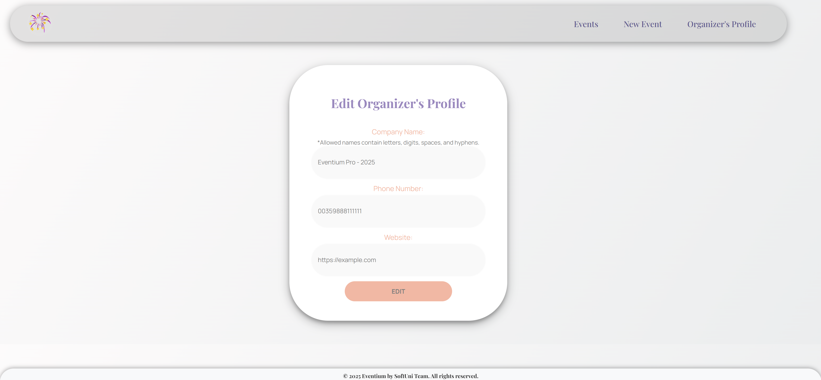

### Delete Organizer's Profile Page - 10 points

**Template file**: **"delete-organizer.html"**

Deleting an organizer's profile should be **possible** **only** if **no upcoming events exist**.

The page displays:

* A **default** **image** from the resources folder (static/images/del.png)
* A warning **message**
* A **button**

After **clicking** the **button**:

* + - * If there are **only older events** (based on start time and 'now') **or no events**:
  + **Delete** the **profile info** **and** **all events**.
    - * If the organizer **has upcoming events**:
  + **Deletion** is **ignored** (there will be **no changes** in the DB).
* The user should be **redirected** to the **Index page**. Display the **correct** navigational links, depending on the **deletion's success**.

